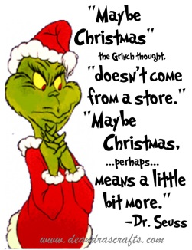
Wear Green for Grinch Day!

We will be having a Grinch Day on Wednesday, Dec. 19th. Students are encouraged to wear green for this fun day. We will be involved in Grinch activities including listening to the story How the Grinch Stole Christmas, making a craft, and solving Grinch story problems. We will be including local preschool students in the fun. A snack will be provided. Please send in a drink for your child. The students will be involved in a sock exchange. Please read the included note.
Have a very, merry holiday!
Mrs. Baur

